LASER METASTASECTOMY IN LUNG METS BREAST CANCER
(Case Report)

Author :
Linda Jana Sintaningtyas

Consultant:
dr. Darmawan Ismail Sp. BTKV

SURGERY DEPARTMENT
SEBELAS MARET UNIVERSITY / RSUD DR. MOEWARDI
SURAKARTA
2018
LASER METASTASECTOMY IN LUNG METS BREAST CANCER : Case Report
Sintaningtyas, LJ ¹, Ismail D ²

¹ Medical Faculty of Sebelas Maret University, Surakarta, Indonesia
² Sub Department Thoracic, Cardiac and Vascular Surgery, Department of Surgery, Moewardi General Hospital, Surakarta, Indonesia

Abstract
Background :Indications and surgical techniques for pulmonary metastasectomy are controversially discussed issues. Numerous retrospective studies have demonstrated that resection of metastases limited to the lungs may be associated with prolonged survival. Laser metastasectomy is a recent innovation that has been advocated especially in patients with multiple pulmonary metastases. The aim of the current study was to describe the first Laser Metastasectomy in patient with lung metastasis breast cancer in Moewardi Hospital Solo.
Objective : A 45 years old woman with carcinoma mammae dextra post MRM on chemotherapy come with lung metastasis. Previous examination reveal that the patient had carcinoma mammae dextra BIRADS 5 with pneumonic type pulmonal metastasis. Laser metastasectomy performed to this patient.
Result : The first time lung metastasectomy with laser have performed to Solo at December 2017. It used laser 1318nm ND Yag. The operation last about 30 minutes, post operative patient was set WSD. Patient stayed for about 7days. No complication found at preoperative, durante and post operative. Patient come to control regularly 1times a month up to now.
Conclusion: Laser metastasectomy was well performed to this patient. This palliative option was promising, safe and increasing life expectancy.
Keyword : carcinoma mammae, lung metastase, laser metastasectomy

INTRODUCTON
The lung is a frequent metastatic site for recurrent breast cancer but the role of pulmonary resection is still under debate, in particular in the results of nonsurgical treatments, like hormon or chemotherapy.¹ Surgical resection is widely employed as a conventional treatment option for patients with lung metastases originating from a wide range of primary tumors.²
From the fundamentals of basic patient selection, to the chosen surgical approach, there is no prevailing evidence that guides practice. The heterogeneity in the biologic behavior of the many primary tumors adds to the difficulty in drawing conclusions from mixed series. The very essence of the practice, that is a belief that pulmonary metastasectomy can prolong survival, has been questioned. ³⁻⁴
Pulmonary metastasectomy (PME) is the only therapeutic option with curative intent for selected patients with pulmonary metastases originating from various solid tumors.⁵
PME can be performed using a number of different surgical techniques, including conventional excision with electrocautery and laser-assisted surgery (LAS). Since the implementation of LAS for PME, this resection technique quickly became popular due to advantages such as ontime coagulation, sparing of lung parenchyma and potentially higher safety regarding local completeness of resection.⁵⁻⁷
CASE PRESETATION
A 45-year-old female patient was admitted to hospital with lung metastasis from breast cancer. She had breast cancer for about one year and MRM had been commenced. Patient admitted to our hospital because of dyspnea. The patient have already undergone chemotherapy. From the result of anatomy pathology laboratory, patient had infiltrating ductal carcinoma mammae (NOS) grade I/II with positive LVI. Hystochemistry examination reveal that esterogen reseptor negative, progesteron receptor positive, HER2/Neu negative (score 1). Radiodiagnostic examination reveal that retroaraeola mammae tumour dextra highly suggestive malignant BIRADS 5, limphonody axillaris anterior dextra metastase, pneumonic type pulmonal metastase at right lung, chemoport in left venae subclavia to superior venae cava, cholelitiasis and cholesisititis. Primary cancer of the patient was well controlled. This patient was planned for lung metastasectomy with laser on December 14, 2017.
On admission at December 12, 2017, the patient was stable. She was normotensive (TD 120/70), heart rate was 80 times perminutes, respiratory rate was normal, 20 times per minutes and oxygen saturation was 100% on room air. She was afebrile. On general examination she looked normal with height 160cm and weight 71kg. The head was atraumatic and normocephalic; pupils were bilaterally equal and reactive. There was no evidence of neck vein distension or pedal edema. A well-healed surgical scar of MRM was noted extending from his left axilla to his sternum. On percussion, the right chest appeared to be dull and on auscultation breath sounds were decreased in the right base in comparison to the left. The abdomen was soft, nontender, and nondistended with normoactive bowel sounds. Tenderness was elicited on palpation of the upper thoracic spine and right scapular area and range of motion of both arms was mildly restricted due to pain and discomfort. Cardiovascular and neurological examination was noncontributory.
On laboratory pre-operative examination at December,12,2017, the patient was found to have normocytic normochromic anemia with hemoglobin of 11,8 gm/dL. The leukocyte count was normal. Metabolic panel and liver function test results were within normal limits. The coagulation panel was normal. The MSCT thorax at November 28, 2017 concluded the mass at retroareola and retronipple right mammae highly suggestive malignant (BIRADS 5), pneumonic type pulmonal metastase, and chemoport showed from left subclavian vein to superior cava vein.
Table 1. Laboratory Preoparative Result
EXAMINATION | RESULT |  | NORMAL | METHODS
Hb | 11,8 | g/dl | 12,0-15,6
Hct | 37 | % | 33-45
AL | 4,4 | x10³ /uL | 4,5-11,0
AT | 178 | x10³ /uL | 150-450
AE | 4,46 | x10⁶ /uL | 4,10-5,10
Eritrocyte Index
MCV | 83,4 | /um | 80,0-96,0
MCH | 26,5 | Pg | 28,0-33,0
MCHC | 31,7 | g/dl | 33,0-36,0
RDW | 11,8 | % | 11,6-14,6
MPV | 8,4 | Fl | 7,2-11,1
PDW | 16 | % | 25-65
Diff Count
Eosinofil | 6,30 | %
Basofil | 0,40 | %
Neutrofil | 57,10 | %
Limfosit | 27,20 | %
Monosit | 9,00 | %
Gol Darah | O |  | AGLUTINATION
Homostasis
PT | 11,6 | Second | Semi automatic
APTT | 33,2 | Second | Semi automatic
INR | 0,890 |  | Semi automatic
Clinic Chemical
GDS | 86 | mg/dl | 60-140 | Hexokinase
SGOT | 27 | u/L | <31 | IFCC tsnps pyridoxal
LPGT | 21 | u/L | <34 | IFCC tsnps pyridoxal
Albumin | 3,5 | g/dl | 3,5-5,2 | BCG
Creatinin | 0,6 | mg/dl | 0,6-11 | Enzimatic
Ureum | 16 | mg/dl | <50 | Enzimatic UV Assay
Electrolyte
Natrium | 139 | mmol/L | 136-145 | DIREK ISE
Kalium | 3,9 | mmol/L | 3,3-5,1 | DIREK ISE
Chlorida | 107 | mmol/L | 98-106 | DIREK ISE
Patologic Hepatitis
HbsAg Rapid | NR |  | NR | ICT

Figure 1. MSCT Thorax
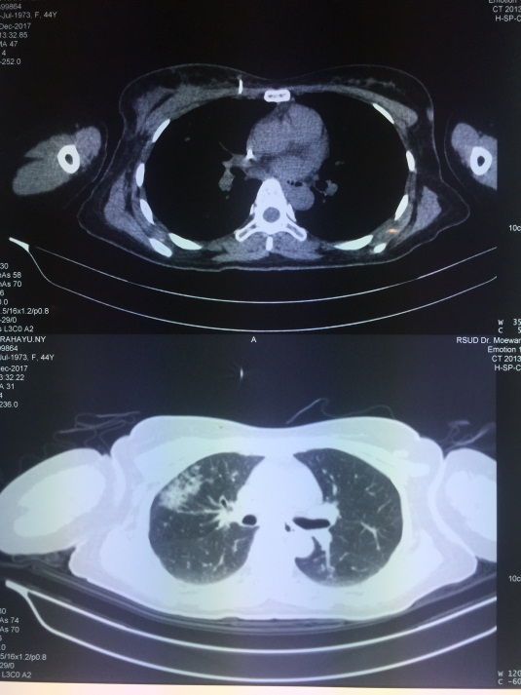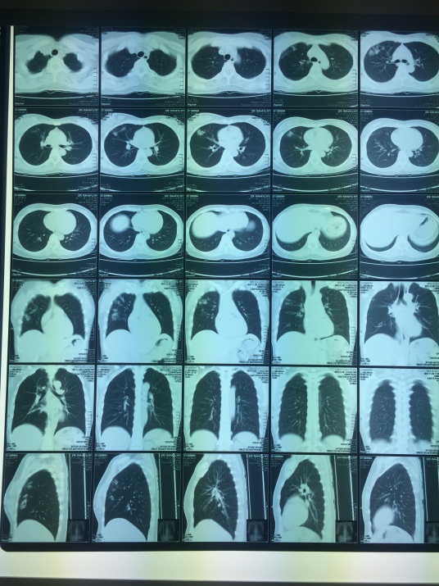
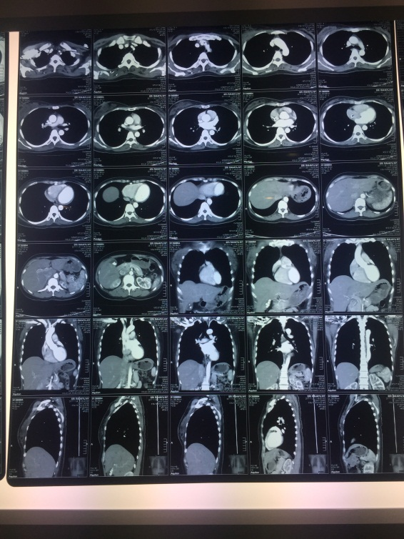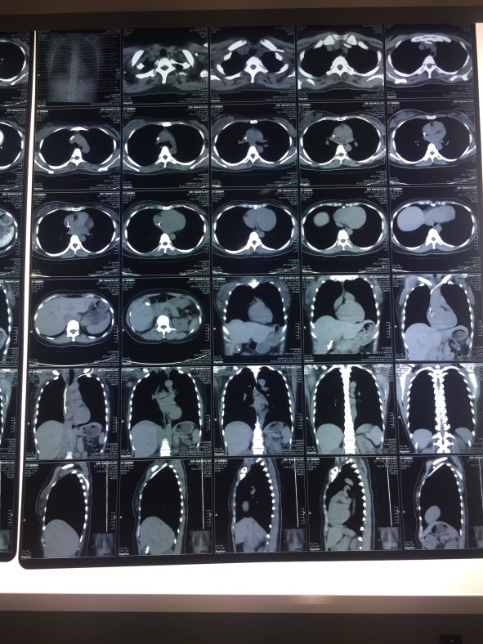

Figure 2. Durante Op
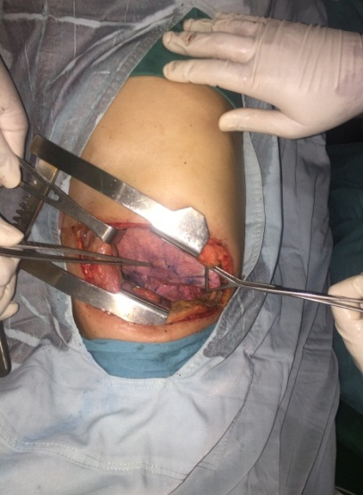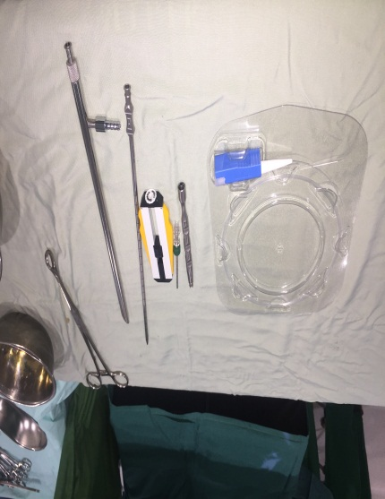
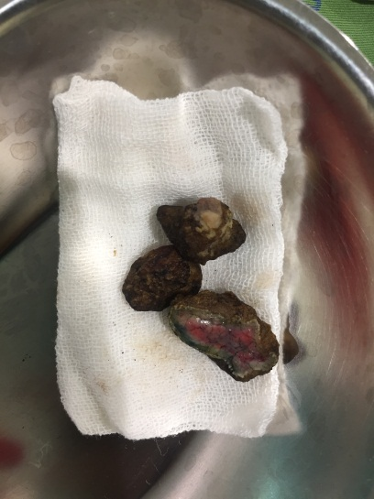

At December 14, 2017 patient undergone the operation. Here is the operation report:
OPERATION REPORT
Pre operative diagnose: lung metastase breast cancer
Post operative diagnose: lung metastase
Operation: thoracotomy exploratory, segmentectomy, chest tube thoracostomy
Operator: Darmawan Ismail, dr, SpBTKV
1. Patient on theatre in half decubitus position in general anesthesia, toilet operation field, hollow sterile doek lid
2. Incised above costa 6 dextra along 10cm, layer by layer, split musc latissimus dorsi (D) and anterior muscle serratus (D), intercostalis muscle of SIC 6 pulmo visualized
3. Identification of metastasis of mammary tumor to lung visible 3 mass size 2x1x1cm, 3x2x1cm, 1x1x1cm (2mass in superior lobe, 1 mass in posterior lobe)
4. Performed excision of tumor with laser control of bleeding
5. Metastatic tumor is stored in formalin 10% specimen send to PA
6. Lung leak test (-)
7. Sew layer by layer
8. Operation is complete
Table 2. Laboratory Result Post Operative (December 14, 2017)

 | RESULT |  | NORMAL | METHODS
Hb | 11,0 | g/dl | 12,0-15,6
Hct | 34 | % | 33-45
AL | 5,6 | x10³ /uL | 4,5-11,0
AT | 159 | x10³ /uL | 150-450
AE | 4,07 | x10⁶ /uL | 4,10-5,10
Clinical Chemical
Albumin | 3,2 | g/dl | 3,5-5,2 | BCG
Electrolyte
Natrium | 135 | mmol/L | 136-145 | DIREK ISE
Kalium | 3,5 | mmol/L | 3,3-5,1 | DIREK ISE
Chlorida | 111 | mmol/L | 98-106 | DIREK ISE
BLOOD GAS ANALYZED
pH | 7,496 |  | 7,350-7,450
BE | 4,2 | mmol/L | -2 - +3
PCO2 | 35,5 | mmHg | 27,0- 41,0
PO2 | 279,4 | mmHg | 83,0- 108,0
Hct | 35 | % | 37-50
HCO3 | 27,7 | mmol/L | 21,0-28,0
Total CO2 | 28,8 | mmol/L | 19,0-24,0
O2 saturation | 99,4 | % | 94,0-98,0
Lactat Artery | 1,80 | mmol/L | 0,36-0,75
The operation was held in 30 minutes. Post operation, patient stayed at Intensive Care Unit. Followup day 1 patient condition was stable, composmentis, and feel pain in scar post operative. Physical examination and the patient condition was normal. Followup day 2, patient was transferred to Pavilliun, WSD was removed, but still complain about scar post operative and sometime feel pain during breathing. Followup day 3, the complaining about pain was reduced, patient started to mobilized tilted to right and left, but still used oxyggen 3liters per minutes by nasal canul. Followup day 4, no complain about scar, patient mobilized to sitting and standing. The complaining about pain during breathing was decreased, iv line and douwer catheter was removed. Followup day 5, the condition patient was stable and allowed to go home with analgetics. The patient was treated with oxygen, antibiotics and analgetics when hospitalized.
Patient come to control after hospitalized 3days later. The physical examination and general condition was normal. Patient control 1times per week until 1month. The condition was stable. Then the patient control 1times per month up to now. Patient also came to policlinic oncologic and was prescribed tamofen.
DISCUSSION
One of the main characteristics of breast cancer is its capability to disseminate. Solitary pulmonary metastases from breast cancer occur rarely (0.4%). Potential prognostic factors affecting survival, namely survival after lung metastasectomy, assessed were disease-free interval (DFI), the number and location of lung metastases, the diameter in mm of metastases and the extent of pulmonary resection.⁸
That was the first time Laser Assisted Pulmonary Metastasectomy (LAPM) held in Moewardi Hospital in Surakarta. It used laser 1318nm ND Yag. The operation last about 30minutes, post operative patient was set WSD. Patient stayed for about 7days. No complication found at preoperative, durante and post operative.
There was some preparation before undergo LAPM. At first, control of primary cancer must be ascertained. Next, routine blood tests, chest X-ray, pulmonary function tests, EKG, blood gas analysis, tumour marker studies, stress testing, abdominal ultrasound, CT-scan, MRI, PET-CT, GI endoscopy etc. are usually considered.^{9, 18}
Limitations of CT-scan in diagnosing lung metastasis must be clearly understood. Firstly, all nodules seen on CT-scan are not metastatic in nature. Many of them, especially in case of breast cancer, could either be non-cancerous or second primary lung cancer. It is for this reason, too, LAPM should be considered as a diagnostic aid paving way for correct treatment. ^{9,17}
Secondly, a most sophisticated CT-scan also misses a metastatic nodule smaller than 3 to 4 mm in size. On the other hand, careful inspection of lung through open chest and exploration by surgeon’s experienced fingers can detect 25% more nodules , as small as 1 mm in diameter, which are missed by CT-scan. It is for this reason that any technique of pulmonary metastasectomy which does not permit digital exploration by surgeon is not a proper way of handling the disease. A clear example of this is Video Assisted Thoracic Surgery (VATS) for this operation. It can leave disease behind which LAPM can easily remove. ^{9,16} At this case, patient have prepared for LAPS. Primary cancer was controlled and routine examination have been done.
For preoperative preparation, the patients undergo thorough medical and anaesthetic evaluation. They work on incentive spirometry during every waking hour. Aggressive chest physiotherapy helps in early recovery. Bronchospasm, diabetes mellitus and hypertension must be controlled well. Smoking must be avoided at least a week prior to surgery. Inhalers, nebulisation and steam inhalation improve lung health. ^{10,17}
At the theatre room, chest is entered through a small cut underneath the armpit. No muscle or rib is cut or removed. A spreader is inserted between the two ribs and ribs are spread apart. Operator carefully inspects and explores the entire lung with fingers. Thus he detects and notes the site and number of cancerous nodules.
All nodules are removed along with a margin of 2-3 mm of healthy lung around them. Operator follows the contour of the nodule and goes all around in the healthy lung. One nodule usually takes 1-2 minutes. Though laser generates temperature of 700 degree Celsius, healthy lung is not damaged. Usually 7-8 nodules are removed from each lung but even 100 can be removed in the same fashion. Very tiny nodules can be vaporised instead removed. Excised tumours can be subjected to pathological studies. Raw areas can be sutured back leaving lung nearly normal. Loss of lung tissue is hardly 10%. There is very little blood loss and hence, no blood transfusion is required. Total operating time varies between 1 and 2 hours. Complication rate is hardly 1 to 2 %. Mortality is rare. ^{10, 16}
For post operative course, most of the patients either do not need any ICU care or need it only for 2 to 24 hours. Most of the pre-operative measures are continued post-operatively. Nasal oxygen cannula stays for 3 to 6 hours. Need for ventilator is very rare. Analgesics-epidural, IV and oral- are given liberally. IV fluids are needed for the first day. Oral liquids are started from the evening of the day of operation and normal diet is started from the next day. Removal of the chest tube and ambulation begin on 2nd or 3rd day. Most often, patient stays in hospital for 3 to 5 days depending on their tolerance to pain. Pre-discharge chest X-ray is taken. At this cases, patient stayed at ICU for 24hours post operative and removal of chest tube on 2nd day. Patient stayed for 5days after operation. ¹⁰⁻¹⁸
Currently, surgical resection remains the gold standard for resectable lung metastases. Prognostic factors are histology, complete resection, number of metastases and disease-free interval.⁹ In breast cancer, chemotherapy is the primary treatment option for patients with lung metastases.¹⁰⁻¹² Metastatic disease of breast cancer responds very well to systemic chemotherapy and/or antihormonal therapy, resulting in an unclear role for surgical resection. Some studies report no benefit in overall survival for patients undergoing complete metastasectomy for breast cancer compared to systemic chemotherapy or to patients undergoing an incomplete resection, whereas others do find a survival benefit. ¹³⁻¹⁶
In selected cases, with a DFI of more than 36 months and complete resection, a long disease-free and overall survival period may be obtained. However, not all lung nodules are metastatic lesions. Rena et al. showed that, in 50% of the patients with a history of breast cancer and a newly diagnosed lung nodule, primary lung cancer was found. Complete surgical resection needs to be performed in this patient group in order to have histological confirmation and a real chance of cure when a primary lung cancer is found. Another study showed that there is a reasonable chance that the hormonal receptor status of the primary tumour is different from the lung metastases, warranting histological evidence to plan further treatment. Although most studies do not find a survival benefit, surgical resection of lung metastases from breast cancer is warranted in selected cases if complete resection can be achieved, if there is suspicion of primary lung cancer and to plan further treatment depending on the hormonal receptor status of the metastases. ^{7,8,10}
Yhim et al. analyzed clinical outcomes of patients suffering from recurrent breast-cancer with less than four pulmonary metastases, treated with systemic treatment alone or lung resection and then systemic treatment, disclosing that pulmonary metastasectomy can be an effective therapeutic option for patients with few and small metastases, irrespective of poor-prognosis aspects.²⁰ Similarly Planchard et al. demonstrated that pulmonary metastasectomy from breast carcinoma was associated with a significant 5-year survival rate of 45%, but were not able to discriminate whether this result was due to the surgical procedure itself or to the selection of patients, the authors emphasized that when resection is evaluated this cohort of patients, both the size of the largest metastasis and the disease free interval should be carefully considered. ²¹
In this case report, from the examination to the patient after lung metastasectomy at December 2017 up to now at July 2018, stiff complain in patient continuously decreased. Although still can not be concluded about post operative survival rate outcome but the implementation of Laser Assisted Pulmonary Metastasectomy (LAPM) can be one of promising alternative palliative therapy for breast cancer patients. Not only minimally invasive but also easy to use and safe.
CONCLUSION
Laser Assisted Pulmonary Metastasectomy (LAPM) is resection or excision of pulmonary metastasis with laser. Any patient with metastasis in lungs must be evaluated for LAPM. If the primary disease is completely under control, the cancer spread is strictly restricted to lungs, the disease in lungs can be completely removed by surgery and patient is physically fit to undergo the surgery, he or she qualifies for LAPM. This method represent a safe and promising way to resect lung mets.
REFERENCES
1. Petrella F, Diotti C et al. Pulmonary Metastasectomy: an Overview. Journal of Thoracic disease. 2017 Jan; 9 (Suppl 12): S1291-8.
2. Internullo E, Cassivi S et al. Pulmonary Metastasectomy: A Survey of Curent Practice Amongst Members of the European Society of Thoracic Surgeons. J Thorac Oncol. 2008;3: 1257–66.
3. Treasure T, Utley M, Hunt I. When Professional Opinion is Not Enough: Surgical Resection of Pulmonary Metastases in Patients with Colorectal Cancer is Common Practice, but Tom Treasure, Martin Utley, and Ian Hunt Question the Strength of Evidence Behind Advice from NICE. BMJ 2007;334:831–832.
4. Treasure T. Pulmonary Metastasectomy: a Common Practice Based on Weak Evidence. Ann R Coll Surg Engl 2007;89:744–748.
5. Franzke K, Natanov R et al. Pulmonary Metastasectomy- A Retrospective Comparison of Surgical Outcomes After Laser-Assisted and Conventional
Resection. Eur J Surg Oncol. 2016; 20: 1-8.
6. Rolle A, Pareszlenyi A, Koch R, Richard M, Baier B. Is Surgery for Multiple Lung Metastases Reasonable? A Total of 328 Consecutive Patients with Multiple-Laser Metastasectomies with a New 1318-nm Nd: YAG Laser. J Thorac Cardiovasc Surg 2006; 131(6): 1236-42.
7. Mineo TC, Ambrogi V, Tonini G, Nofroni I. Pulmonary Metastasectomy: Might the Type of Resection Affect Survival? J Surg Oncol 2001; 76(1): 47-52.
8. Kycler W, Laski P. Sugical Approach to Pulmonary Metastases from Breast Cancer. The Breast Journal 2011; 18 vol I.
9. Hornbech K, Ravn J, Steinbruchel DA. Current Status of Pulmonary Metastasectomy. European Journal of Cardio-Thoracic Surgery. 2011; 39: 955-62.
10. Sternberg DI, Sonett JR. Surgical Therapy of Lung Metastases. Semin Oncol 2007;34:186-96.
11. Yano T, Shoji F, Maehara Y. Current Status of Pulmonary Metastasectomy from Primary Epithelial Tumors. Surg Today 2009; 39:91-97.
12. Kesler KA, Wilson JL, Cosgrove JA, et al. Surgical Salvage Therapy for Malignant Intrathoracic Metastases from Non-Seminomatous Germ Cell Cancer of Testicular Origin: Analysis of a Single-Institution Experience. J Thorac Cardiovasc Surg. 2005;130:408-15.
13. Tanaka F, Li M, Hanaoka N et al. Surgery for Pulmonary Nodules in Breast Cancer Patients. Ann Thorac Surg 2005;79:1711-4.
14. McDonald ML, Deschamps C, Ilstrup DM et al. Pulmonary Resection for Metastatic Breast Cancer. Ann Thorac Surg 1994;58:1599-602.
15. Planchard D, Soria JC, Michiels S et al. Uncertain benefit from Surgery in Patients with Lung Metastases from Breast Carcinoma. Cancer 2004;100:28-35.
16. Welter S, Jacobs J, Krbek T et al. Pulmonary Metastases of Breast Cancer. When is Resection Indicated? Eur J Cardiothorac Surg 2008;34:1228-34.
17. Xiao W, Zheng S,Liu P et al. Risk Factors and Survival Outcomes in Patient With Breast Cancer and Lung Metastasis: a Population Based Study. Cancer Med. 2018 Mar; 7(3): 922–930.
18. Macherey S, Mallmann P et al. Lung Metastasectomy For Pulmonary Metastatic Breast Carcinoma. Geburtshilfe Frauenheilkd. 2017 Jun; 77(6): 645–650.
19. Rolle A, Koch R et al. Lobe-Sparing Resection of Multiple Pulmonary Metastases With a New 1318nm Ng:Yag Laser- First 100 patients. Ann Thorac Surg 2002;74:865–9.
20. Yhim HY, Han SW, Oh DY et al. Prognostic Factors for Recurrent Breast Cancer Patients with an Isolated, Limited Number of Lung Metastases and Implications for Pulmonary Metastasectomy. Cancer. 2010;116:2890-901.
21. Planchard D, Soria JC, Michiels S et al. Uncertain Benefit from Surgery in Patients with Lung Metastases from Breast Carcinoma. Cancer. 2004;100:28-35.

